# 

# Pharmacy Management System



**Session 2023 - 2027**

**Submitted By:**

Salman Naseem 2023-CS-78

Huzaifa Arshad 2023-CS-86

Zohaib 2023-CS-181

**Submitted To:**

Dr. Amjad Farooq

**Course:**

CSC-103 Database Systems

Department of Computer Science

**University of Engineering and Technology**

**Lahore Pakistan**

TABLE OF CONTENTS

1. Description 3

2. Users of Application 3

1. Admin: 3

2. Pharacist: 3

3. Pharmacy Technician: 3

4. Customers ………………………………………………………………………………….3

3. Functional Requirements 4

4. ER-Model.……………………………………………………….………………………...….6

5. WireFrames………………………………………………………………………………… 13

# Project Description

This Pharmacy management system project holds all the basic operations of professional pharmacy management system. In this project, there are 4 users. Admin can manage the employees. Pharmacist deals with customers and pharmacy technicians. Pharmacy technician can only place customer orders. Customer can view his medicine purchasing history and can update his profile. It is user friendly project.

## Design

The whole project consists of 3 sub-projects:

1. **Project Library:** This system encompasses the essential components of a Pharmacy Management System, including classes for business entities in the Business Layer and a Data Layer responsible for data management. Within the Data Layer, the Database folder manages data using database connections and SQL queries, while the File Handling folder specifically handles match data. The Data Layer Interfaces folder contains interfaces for the Data Layer classes. C# is utilized extensively in the backend development of this foundational library for the application.
2. **Window Forms Project:** This component comprises the front-end interface of the application, integrating user-friendly Windows Forms that seamlessly interact with the Project Library to ensure optimal application performance.
3. **Console Application:** This component features a Console Application dedicated to executing CRUD operations for the Match entity within the system

# Project Features

There are a total of **four users** in my project:

## Admin:

* Manage Employees ( Add, delete , update, view)
* He can view All stock
* View Sale
* View feedbacks recorded by customer
* Make Announcement to users and customers

## Customer:

* Update his profile
* They can provide feedback on products and services.
* Customers have the ability to change their password and manage their own account.

## Salesman:

* The Salesman role is focused on sales management and analysis.
* Responsible for conducting sales transactions and generating sales reports.
* Provides sales analysis and reports to the Admin for review and decision-making.
* May assist in inventory management and related sales tasks.

# User Functionality

|  |  |  |
| --- | --- | --- |
| Admin | Functions |  |
| Add Employee |
| Delete Employee |
| Update Employee Record |
| View Medicines Stock |
| View Sale |
| View Feedbacks |
| Announce Messages |
| View Analysis |
| **Pharmacist** | Add Medicine Stock |
| Delete Medicine Record |
| Update Medicine Data |
| View Customers |
| Return Medicine |
| Announce Free Medical Camp |
| Pharmacy Technician | Place Customer orders |  |
| View Profile |
| Receive Notifications |
| Manage Customers |
| Customer | View Profile |  |
| Update Profile |
| Check Medicine Buy record |
| Receive Notifications |
| Record a feedback |

1. **ER-Model**

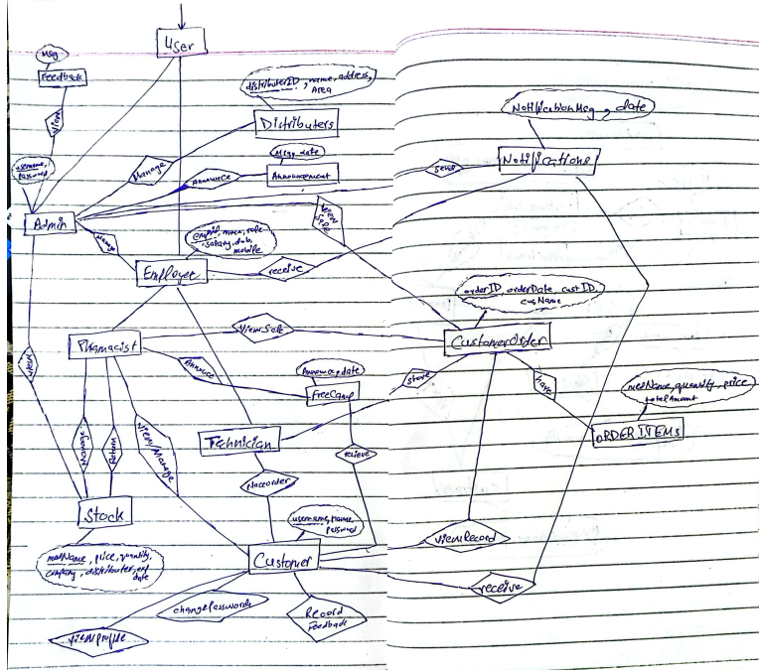

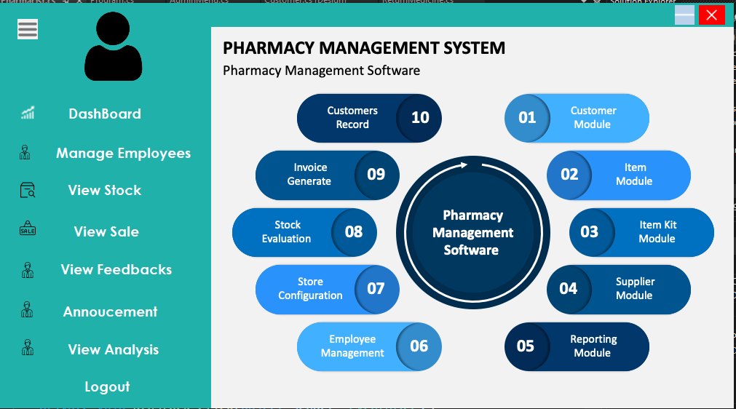

Admin Menu

+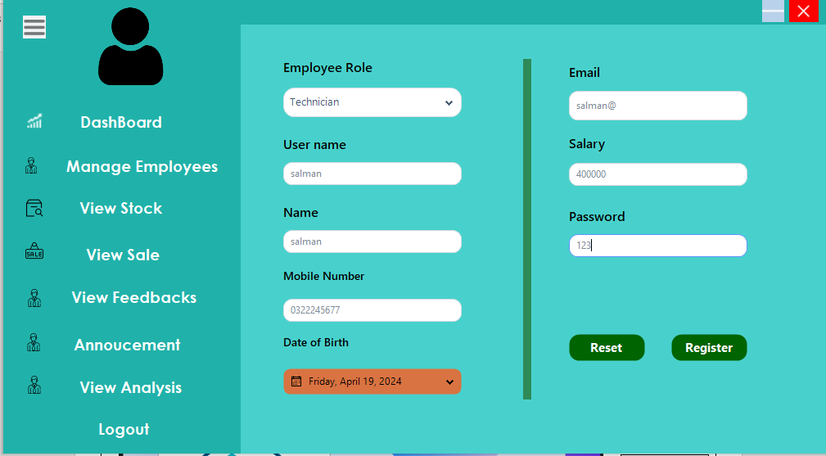

Add Employee

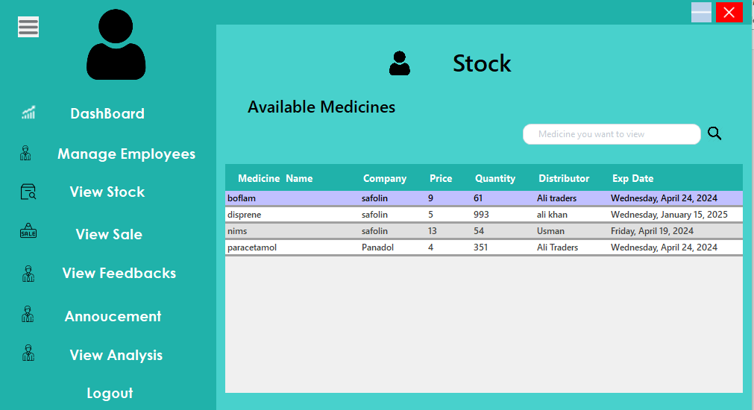

View Sale

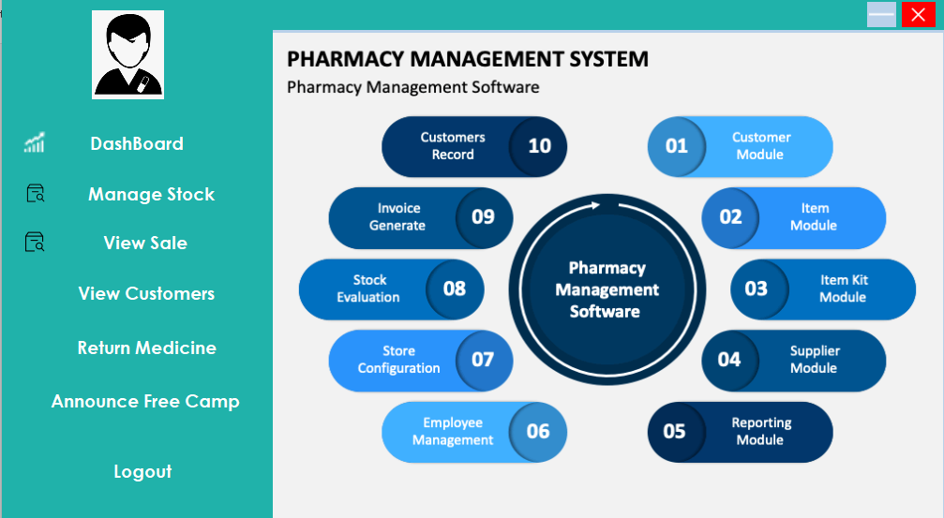

Pharmacist

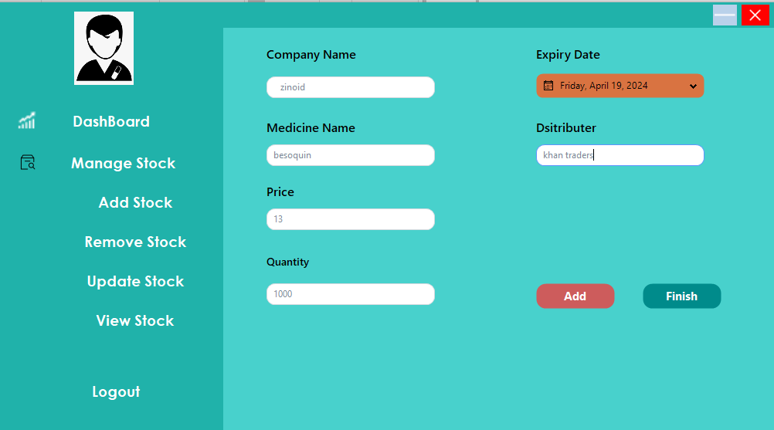

Add Medicine Stock

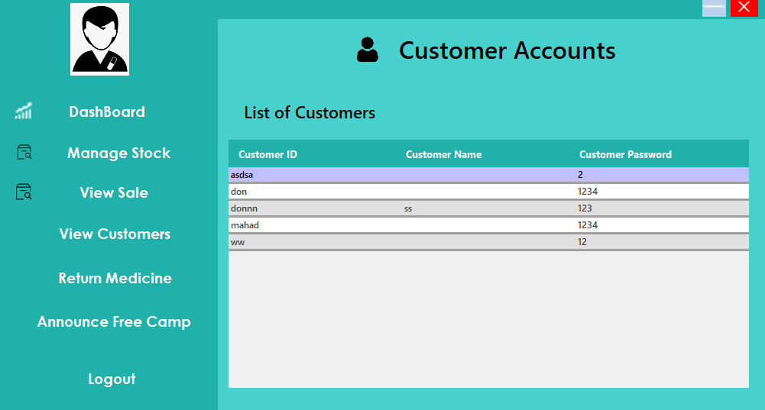

Manage Customers

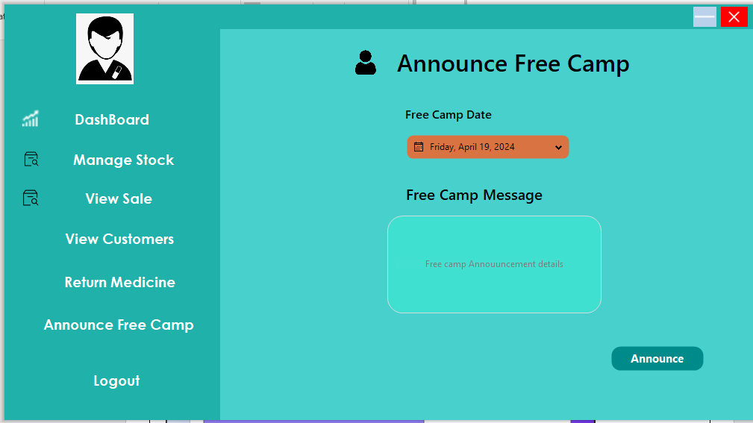

Annouce Free Camp

Pharmacy Technician

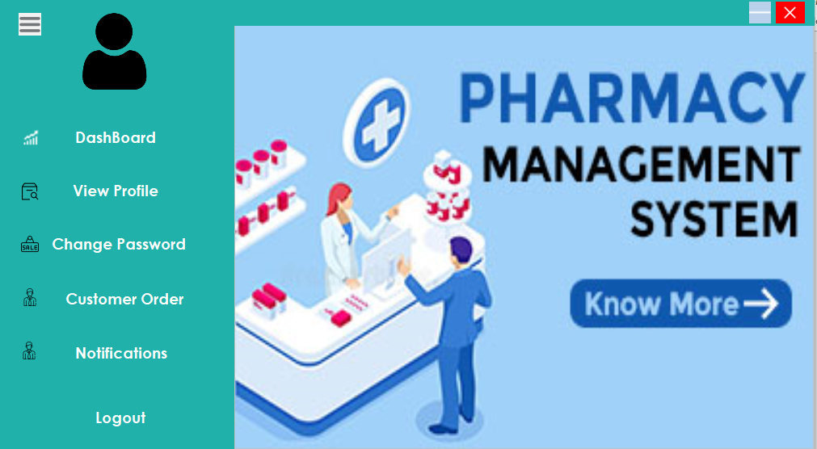

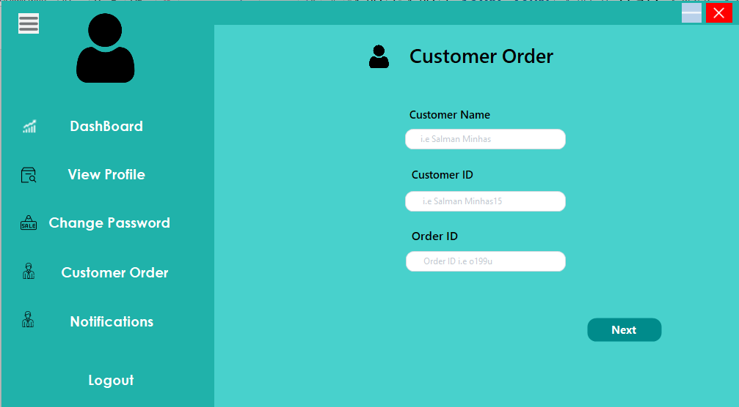

Customer Order

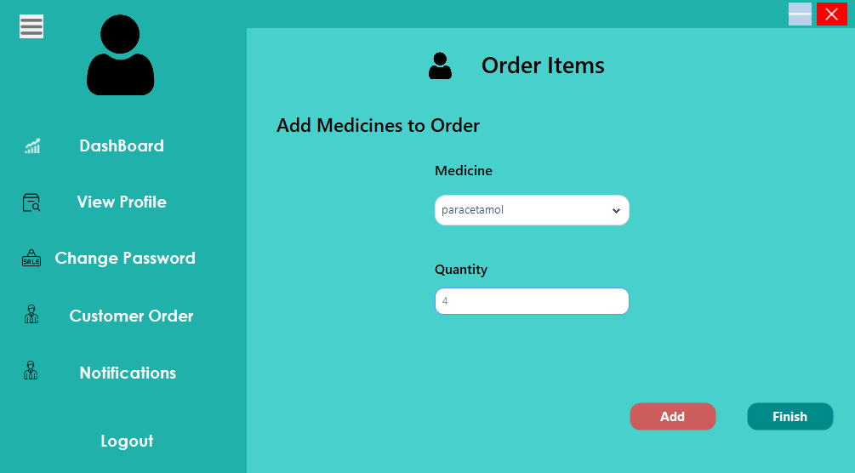

Add medicines to order

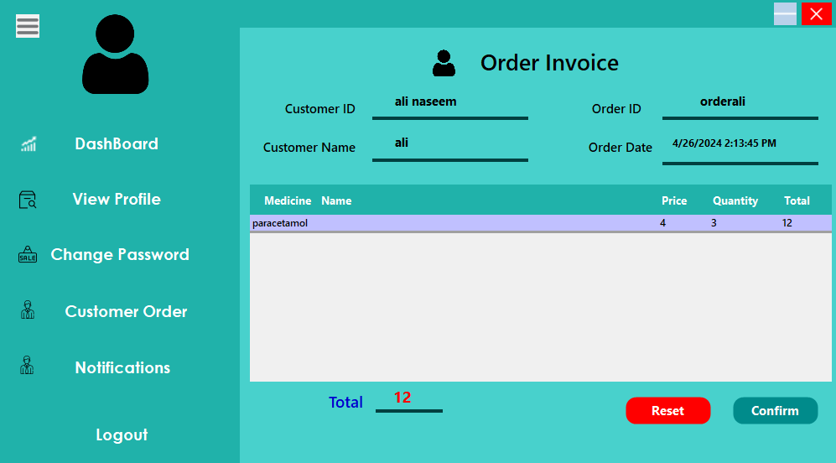

Order Invoice

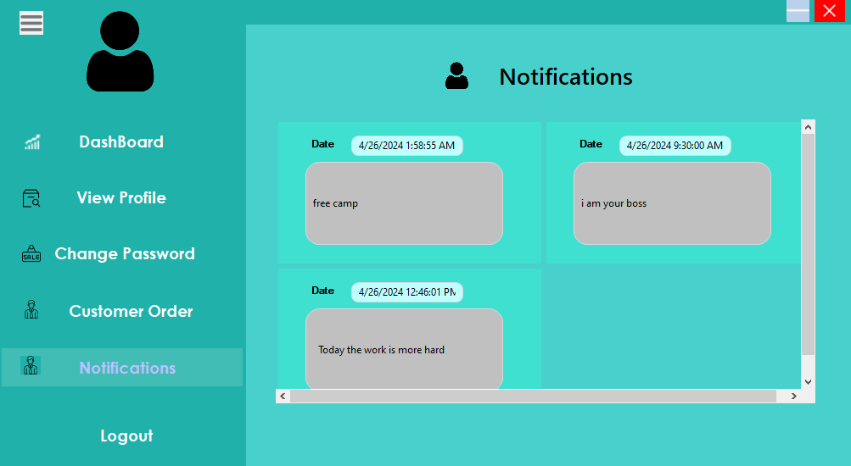

Notifications

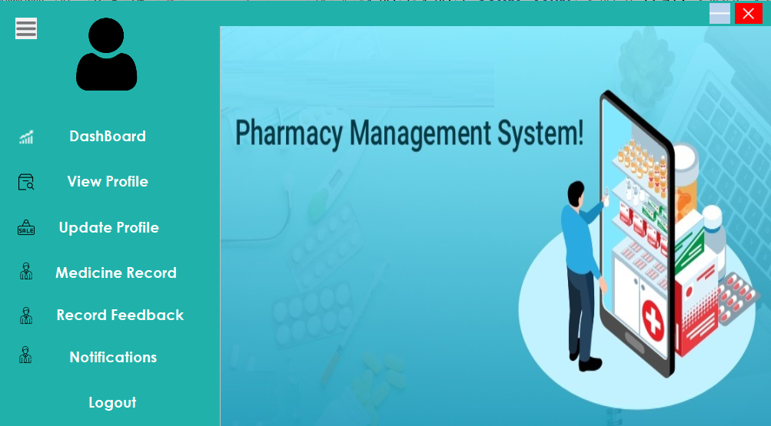

Customer Menu

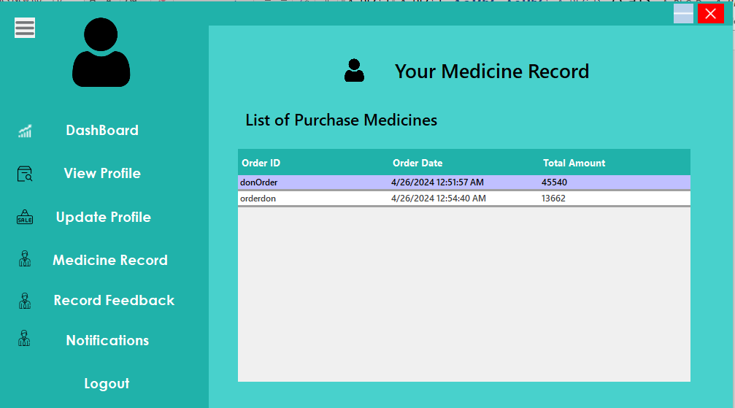

View medicine purchasing history

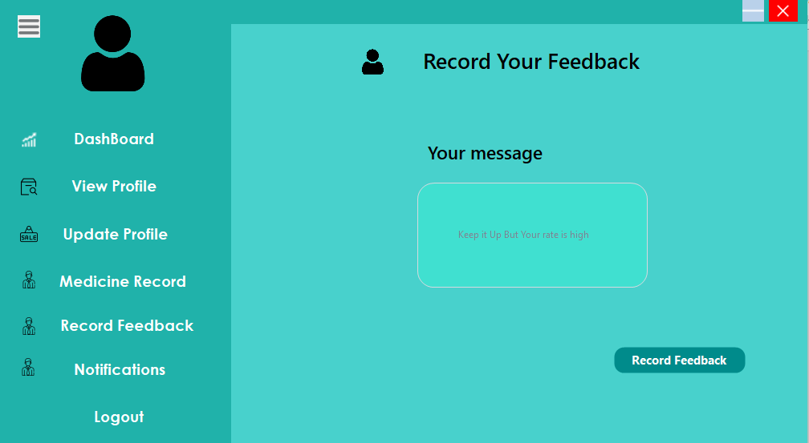

Record Feedback